Video Upload

Video to Efficiency - Video Upload Guide

Klarity is an AI platform that helps you and your team to capture your work, identify improvement opportunities, and create polished documents in minutes. As a process expert, your contributions are critical!

The first step to improving any process is understanding the current state. Klarity Analyst achieves this by interviewing process experts and accepting existing docs and recordings to understand how work is done.

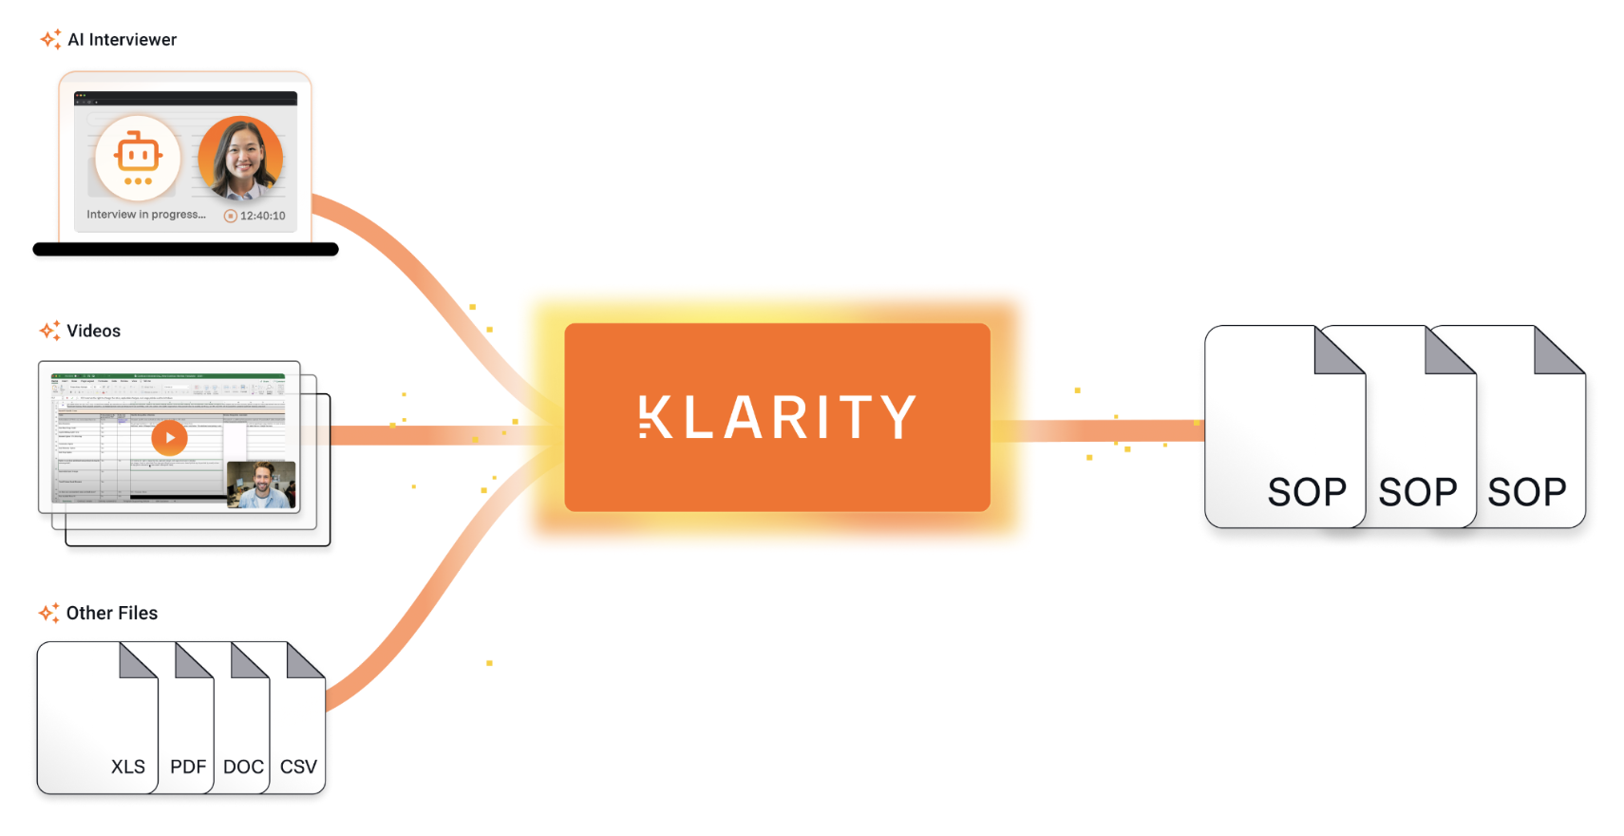

Getting Started

BEFORE YOU BEGIN
- Currently supported file formats are docx, pdf, xlsx, mp4, wmv, and webm. | - A maximum of 5 files per process are supported.

STEP 1: Access Klarity, find your process
- Navigate to app.klarity.ai and enter your credentials to log in. Type your name or process in the Process Hierarchy search bar
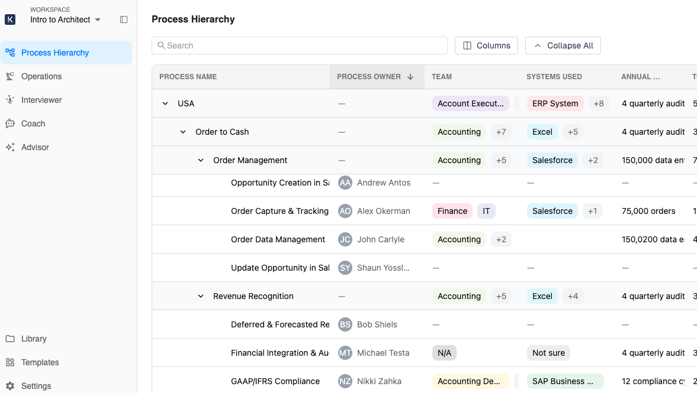

STEP 2: Record a video and upload
- Record your process activity using any capture software (Teams, Zoom, Google Meet, etc…)
- Select your from the hierarchy and click + Start a new Capture.
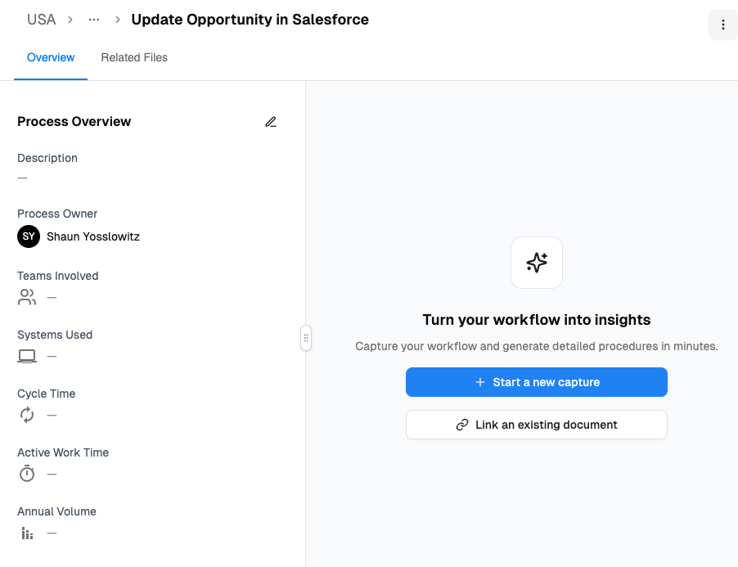
If a process is occupied, do not replace it. Add a process activity leaf node by clicking the + Process button.

STEP 3: Generate your Document
- Drag and drop your recording or documents and select your Template (e.g. Klarity Default SOP)
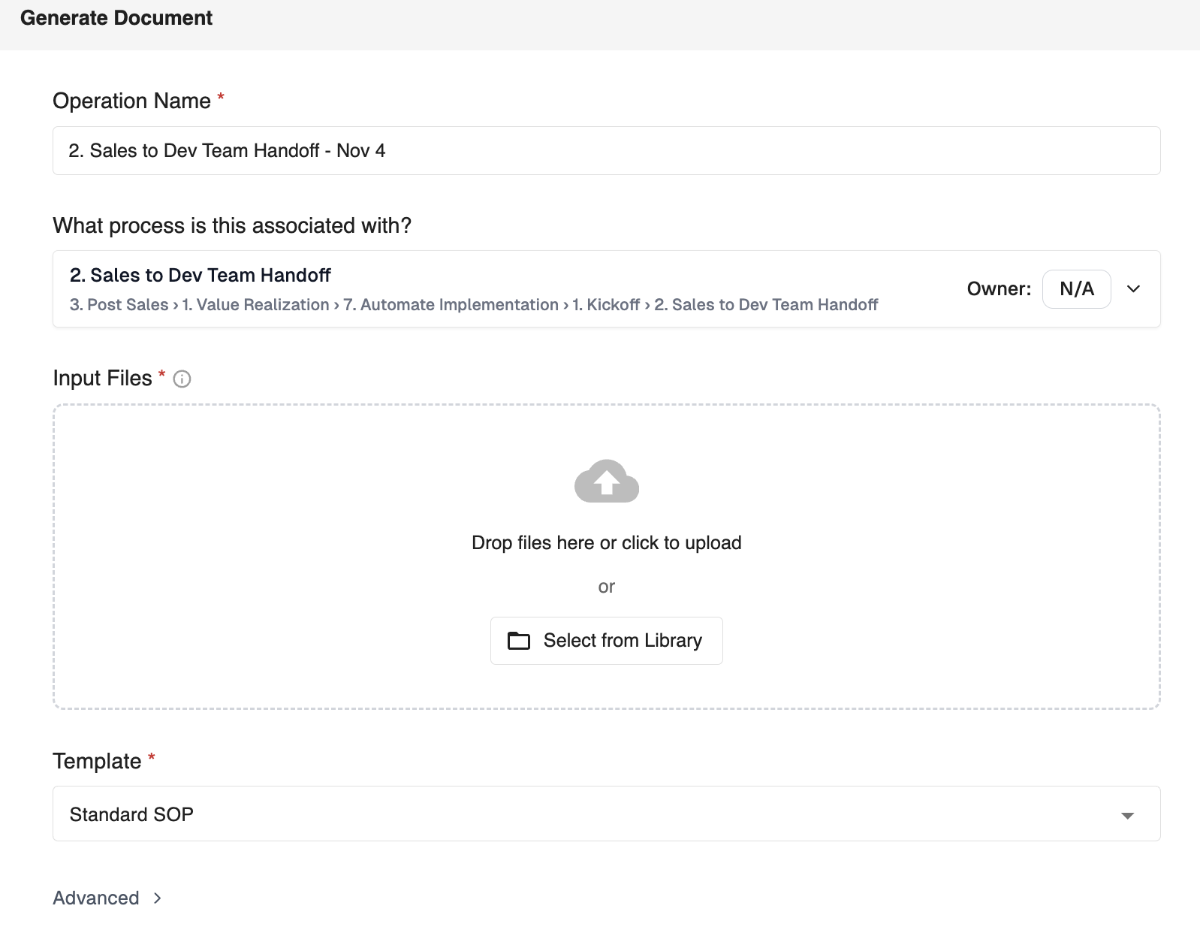

- Under advanced, select the Output Folder (navigate to your process) then click Run Operation

STEP 4: Review Output and Find Your Efficiencies!
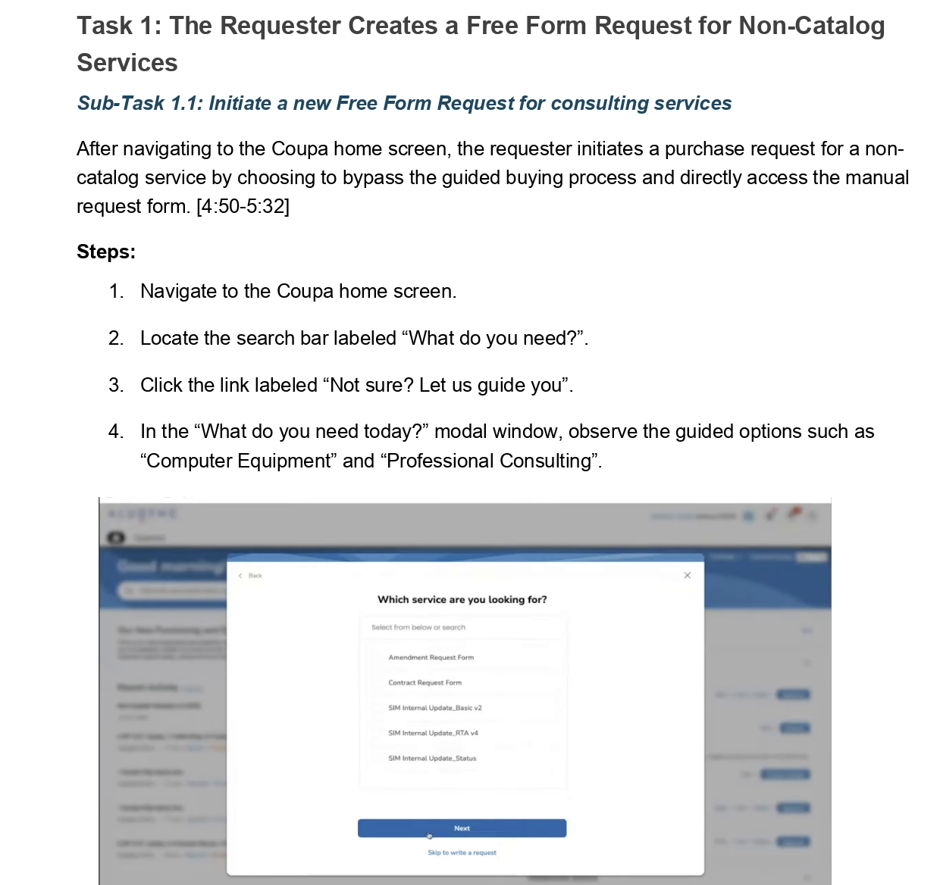
- Take a break and let Klarity finish its analysis and document generation. You will receive an email notification when complete.

- Review your current state capture and use the AI companion agent to find improvements, ask questions or edit the document.
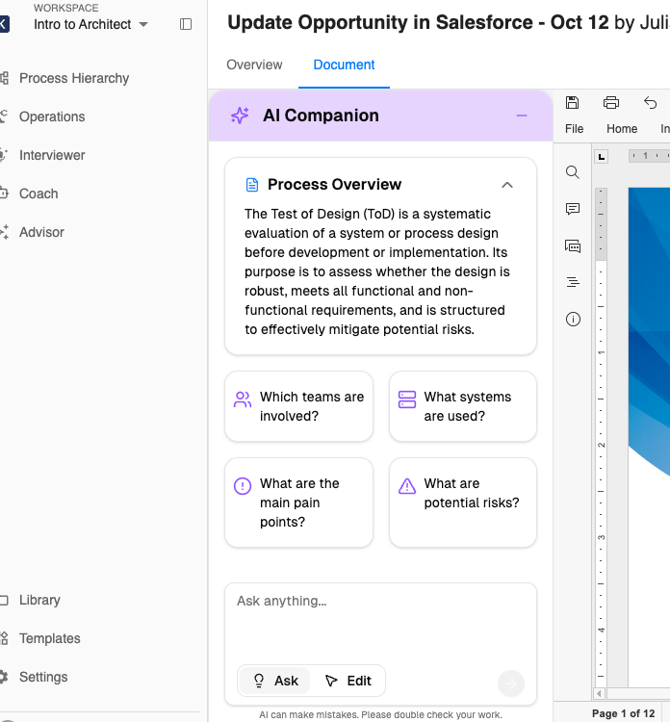

- Try it out! Copy and paste “We use ChatGPT - what are some ways I can use these to reduce the effort of this work?” and click enter.

VIDEO GUIDES
To help you and your team get the most out of Klarity, we have an Enablement Academy. This hub is designed to make the platform as self-serve as possible so you don’t have to wait on us to keep your work moving forward.
Inside, you’ll find:
- Quick videos answering common questions (e.g., “How do I record for the best output?”)
- Tips & best practices based on your direct feedback
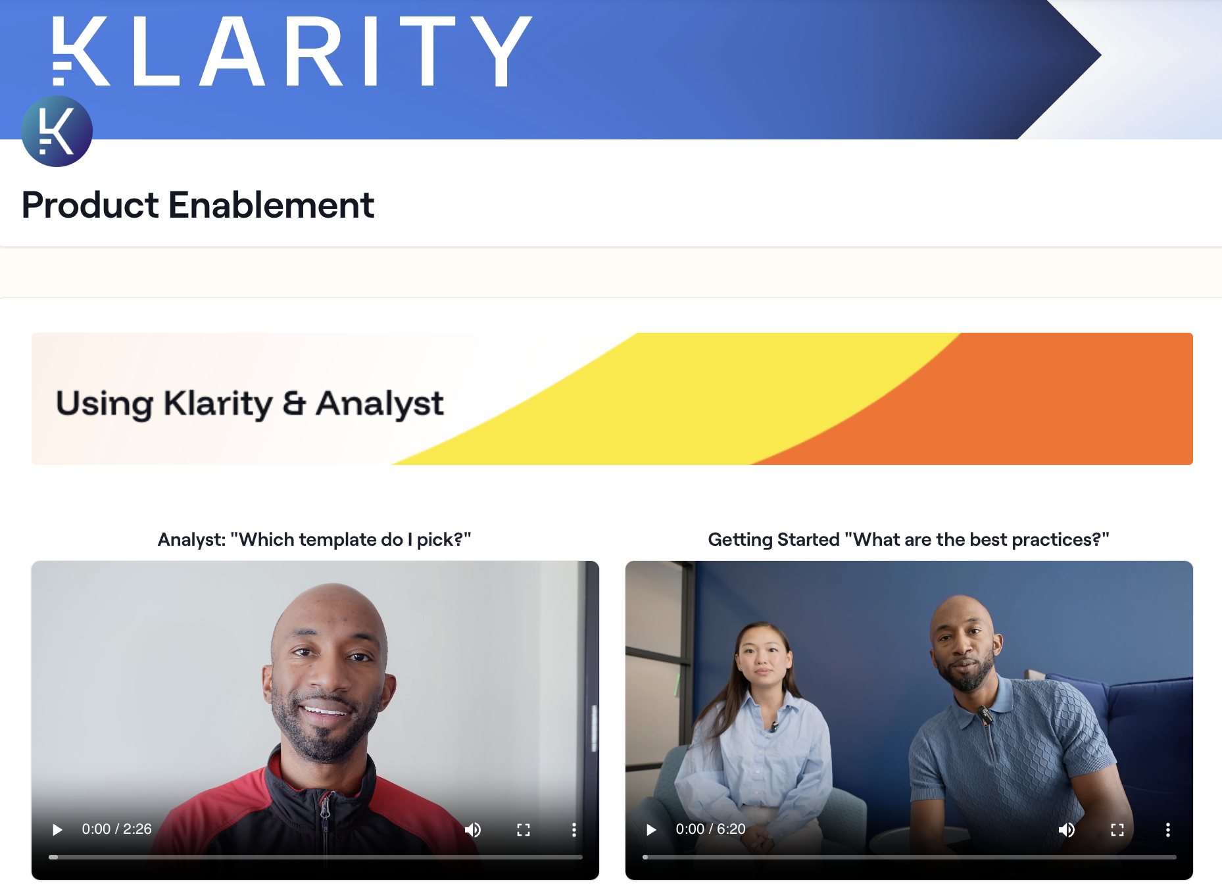
We’ll continue to add new content, so check back often!

AI Interviewer

Video to Efficiency - AI Interviewer Guide

Klarity is an AI platform that helps you and your team to capture your work, identify improvement opportunities, and create polished documents in minutes. As a process expert, your contributions are critical!

The first step to improving any process is understanding the current state. Klarity Analyst achieves this by interviewing process experts and accepting existing docs and recordings to understand how work is done.

Getting Started

BEFORE YOU BEGIN
- AI interview sessions are currently restricted to 30 minutes max - but this is typically more than enough time.  - Pick a quiet spot with minimal background noise. | - AI interview sessions work best when one person can cover most of the details of the process (we recommend recording and uploading a Zoom/Teams meeting when more than one person needs to explain the process).

STEP 1: Access Klarity and launch Interviewer
- Access app.klarity.ai and click the Interviewer button on the lefthand pane.
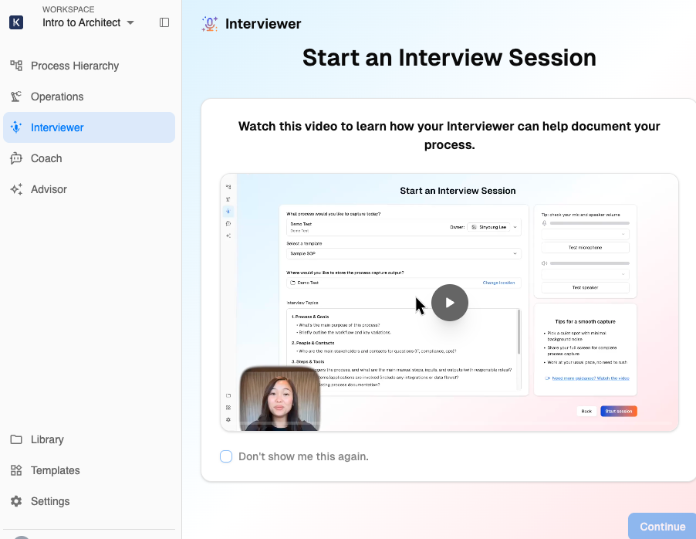
- Allow access and test your microphone before starting the recording.
- Enter the information in the Start an Interview Session section.
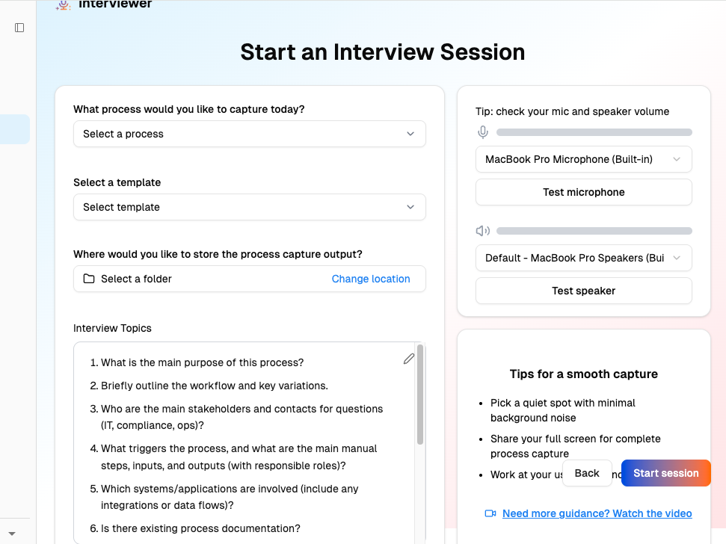
- When you are ready to begin, click the Start Session button and share your screen to ensure Analyst can capture all work.

STEP 2: Record your session
- Perform your process from beginning to end. Talk through the work as you go - the steps you take, the decisions you make, and any important details.
You can adjust your session by clicking the related icons:
  - Re-share your screen or window
  - Mute your microphone
  - Pause the recording

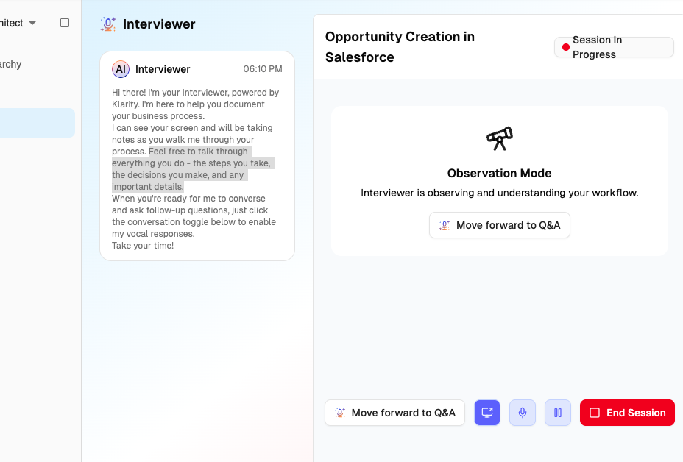

STEP 3: End the session
- To end the interview, click the End Session button.

- The AI Interview may ask additional follow up questions.

- Take a break and let Klarity finish its analysis and document generation. 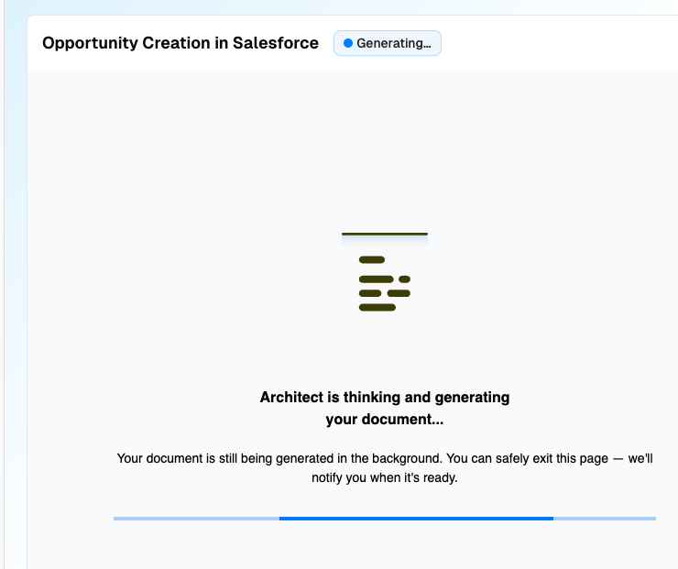

You will receive an email notification when this is completed. The process typically takes 5-10 minutes. You can navigate directly to the completed document by clicking the link in the email.

STEP 4: Review Output and Find Your Efficiencies!
- Review your current state capture and use the AI companion to find improvements, ask questions or edit the document.

- Try it out! Copy and paste “We use ChatGPT - what are some ways I can use these to reduce the effort of this work?” and click enter.

VIDEO GUIDES
To help you and your team get the most out of Klarity, we have an Enablement Academy. This hub is designed to make the platform as self-serve as possible so you don’t have to wait on us to keep your work moving forward.
Inside, you’ll find:
- Quick videos answering common questions (e.g., “How do I record for the best output?”)
- Tips & best practices based on your direct feedback
We’ll continue to add new content, so check back often!

Step By Step

Klarity Submission Guide: From Process to SOP

Klarity is an AI platform that helps you and your team to capture your work, identify improvement opportunities, and create polished documents in minutes. As a process expert, your contributions are critical!

The first step to improving any process is understanding the current state. Klarity Analyst achieves this by interviewing process experts and accepting existing docs and recordings to understand how work is done.

This guide walks you through how to upload - or record - your process walkthroughs and documentation using the Direct Document & Video Upload process

Step-by-step instructions

Logging In & Reviewing Your Processes

STEP 1: Log into Klarity
- Navigate to app.klarity.ai. Enter your credentials to log in. This will take you to the workspace homepage.

STEP 2: Review your Processes
- On the homepage, type your name or process in the Process Hierarchy search bar to see processes that are assigned to you or your teams as the Process Owner. These are the processes where you have been asked to share your expertise.

If a process is occupied, do not replace it. You will add an additional process by clicking the + Process button.

- You’re ready to start a new recording or upload a document for a process! For instructions for each option, see:
  - Recording a New Video with Klarity AI Interviewer
  - Uploading an Existing Video or Document

Uploading an Existing Document or Video

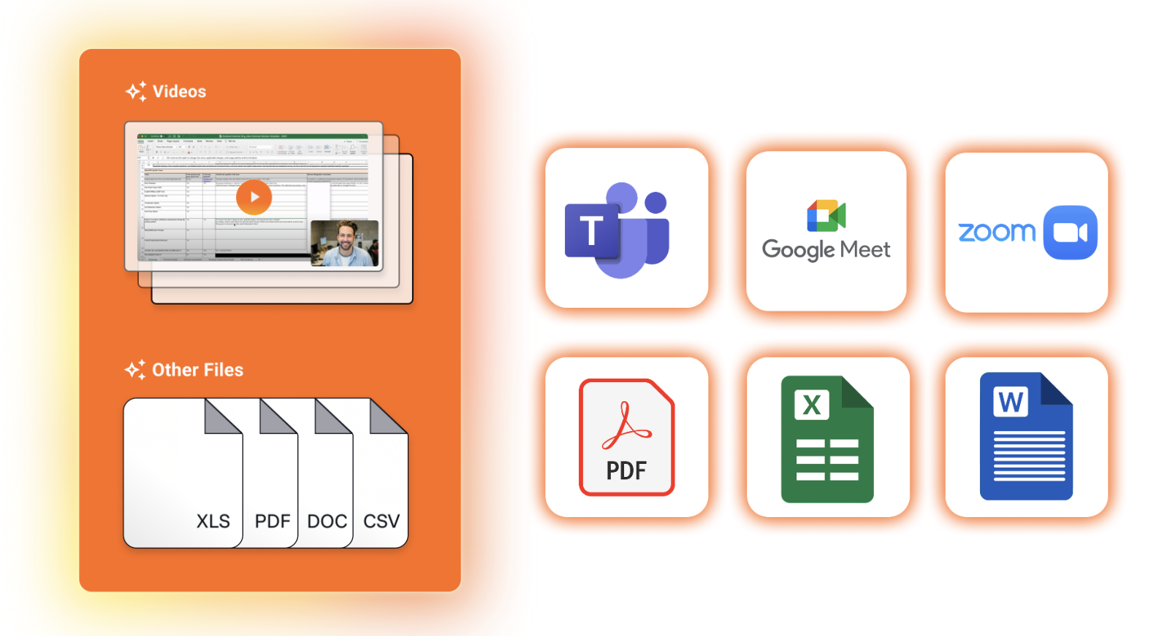

BEFORE YOU BEGIN
- Currently supported file formats are docx, pdf, xlsx, mp4, wmv, and webm. | - A maximum of 5 files per process are supported.

STEP 1: Record your Video
- When you execute your process activity, launch your preferred screen capture software (Teams, Zoom, Google Meet, etc…) and record the activity from start to finish.

- Save the recording to your desktop.

STEP 2: Navigate to Your Process
- Access app.klarity.ai and, click the name of the Process you wish to add documentation to. If a process is occupied, do not replace it. You will add an additional process by clicking the + Process button.

- Klarity will complete the process information for you after your recording or file is uploaded. Be sure to validate them after Klarity fills them out and modify as needed.

STEP 3: Upload Your Recording or Documentation
- To upload existing documentation or process recordings, click + Start a new Capture.

- Review and confirm that the Operation Name and Associated Process are correct. Typically, you can leave them as is. 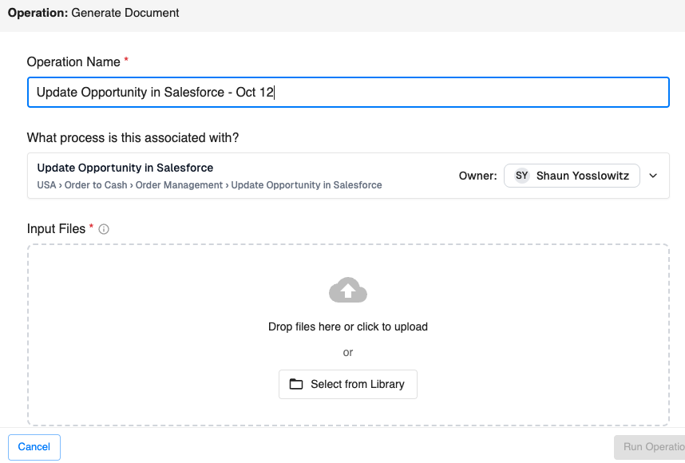

- Upload the process documents and/or recording related to the process in the Input Files section. You can drag and drop them to upload.
  - Currently supported file formats: docx, pdf, xlsx, mp4, wmv, webm
  - Maximum 5 files per process are currently supported.

- Select the Template for the type of end result document that Klarity should generate.

- Select the Output Folder for the document that Klarity will generate.

- Under the Advanced section, in the Additional Instructions area, you can add additional instructions for Klarity to keep in mind when generating the final document.

- Click Run Operation when you have added all relevant documents and recordings to begin Klarity’s document generation.

STEP 4: Generate Your Process Documentation
- Click Run Operation when you have added all relevant documents and recordings to begin Klarity’s document generation.

- Take a break and let Klarity finish its analysis and document generation.

You will receive an email notification when this is completed. You can navigate directly to the completed document by clicking the link in the email. 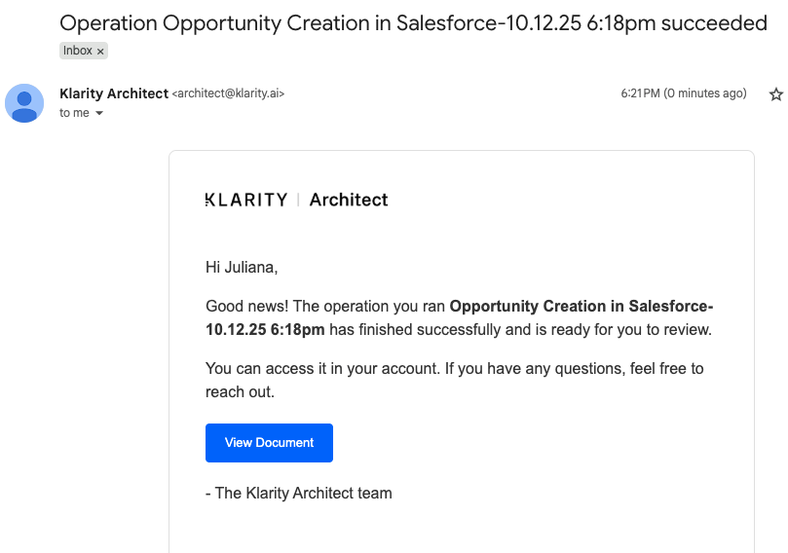

- Your document has been generated! You can now review the document and ask questions about the document within Klarity using the AI Companion feature.

- Try it out: Copy and paste “We use Copilot & ChatGPT - what are some ways I can use these to reduce the effort of this work?” and click enter.

Additional resources v2

ADDITIONAL RESOURCES

[EXT] Klarity Architect: Video Walkthrough Guide Contains a list of recommended topics to cover when recording a process walkthrough.
[EXT] Klarity Architect: User Guide This guide offers an introduction to Architect, instructions for getting started, and best practices for getting the most out of the product.

VIDEO GUIDES

To help you and your team get the most out of Klarity, we have an Enablement tab in your portal. This hub is designed to make the platform as self-serve as possible—so you don’t have to wait on us to keep your work moving forward.
Inside, you’ll find:
- Quick videos answering common questions (e.g., “What's the process hierarchy?”)
- Step-by-step guides on how to to submit template requests
- Tips & best practices based on your direct feedback
We’ll continue to add new content as we grow, so check back often.
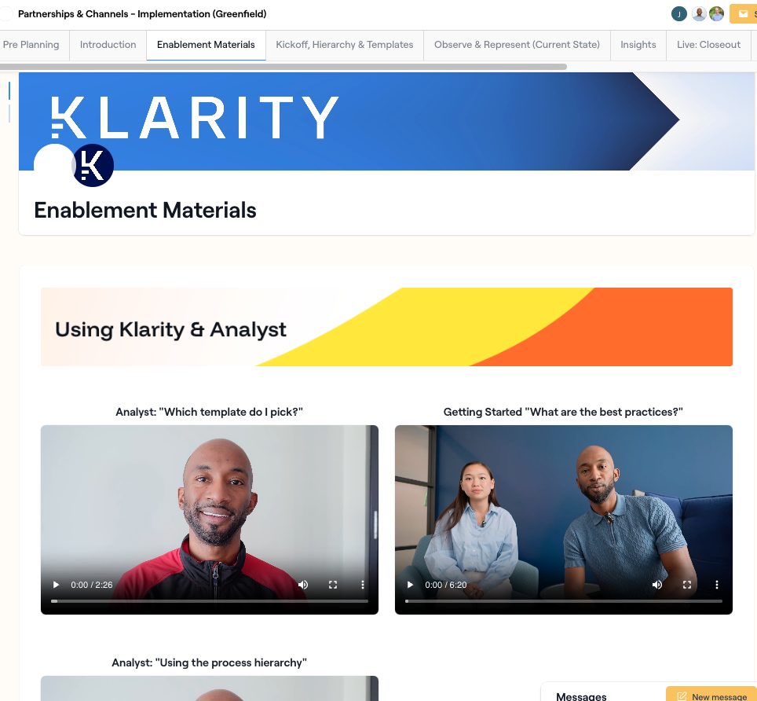

SUPPORT

For any other questions or issues, please reach out to your CSM or our support team at support@klarity.ai. Thanks for using Klarity!

